Lab Evaluation:

Course Name: Object Oriented Programming |  |  |  | Course Code: CMPE 221L
Assignment Type: Lab |  |  |  | Dated: 1-7-2026
Semester: 2rd |  |  |  | Session: 2025
Lab/Project/Assignment #: 12 |  |  |  | CLOs to be covered: CLO1
Lab Title: Implementation of GUI |  |  |  | Teacher Name: Hafiz Muhammad Mubashar
CLO1 | Implement abstraction and encapsulation to develop reusable classes for objects of real-world problems
Levels (Marks) | Level1 | Level2 | Level3 |  | Level4 | Level5 | Level6
(10)
Total |  |  |  |  |  |  | /10

Rubrics for Current Lab Evaluation
Scale | Marks | Level | Rubric
Excellent | 9-10 | L1 | Submitted all lab tasks, BONUS task, have good understanding.
Very Good | 7-8 | L2 | Submitted the lab tasks but have good understanding
Good | 5-6 | L3 | Submitted the lab tasks but have weak understanding.
Basic | 3-4 | L4 | Submitted the lab tasks but have no understanding.
Barely Acceptable | 1-2 | L5 | Submitted only one lab task.
Not Acceptable | 0 | L6 | Did not attempt

LAB No. 12
Lab Goals/Objectives:

• Getting Started with Java
• Acquiring practice with familiar programming constructs in JAVA

University Of Engineering and Technology, Lahore Computer Engineering Department
Equipment Required: Inteli J IDEA Edition Community, Net Beans with JDK 13 Version, Visual Studio.
Theory/Relevant Material: Write First Java Program
1.Write a Java program using Java Swing to create a simple GUI that displays the five daily Namaz timings. The GUI should contain a title and labels showing the prayer names along with their corresponding timings.

TASK 1:
import javax.swing.*;

public class NamazTimingsGUI {

public static void main(String[] args) {

JFrame frame = new JFrame("Namaz Timings");
frame.setSize(350, 300);
frame.setLayout(null);
frame.setDefaultCloseOperation(JFrame.EXIT_ON_CLOSE);

JLabel title = new JLabel("Today's Namaz Timings");
title.setBounds(90, 20, 200, 30);

JLabel fajr = new JLabel("Fajr : 4:30 AM");
fajr.setBounds(50, 60, 200, 25);

JLabel dhuhr = new JLabel("Dhuhr : 12:30 PM");
dhuhr.setBounds(50, 90, 200, 25);

JLabel asr = new JLabel("Asr : 4:15 PM");
asr.setBounds(50, 120, 200, 25);

JLabel maghrib = new JLabel("Maghrib : 6:45 PM");
maghrib.setBounds(50, 150, 200, 25);

JLabel isha = new JLabel("Isha : 8:15 PM");
isha.setBounds(50, 180, 200, 25);

frame.add(title);
frame.add(fajr);
frame.add(dhuhr);
frame.add(asr);
frame.add(maghrib);
frame.add(isha);

frame.setVisible(true);
}
}

RESULT:

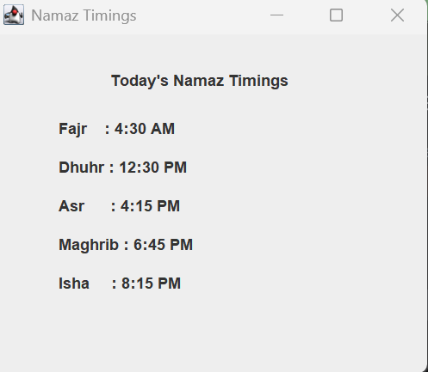

CONCLUSION:
This program demonstrates the basics of creating a Graphical User Interface (GUI) in Java using the Swing library. It uses components such as JFrame and JLabel to display Namaz timings in a simple and user-friendly window. The program helps in understanding how GUI applications are created in Java and how information can be presented visually instead of using the console.

